**E-Commerce Sales Dashboard**

DESCRIPTION

Background

E-commerce is fast gaining ground as an accepted and used business paradigm. More and more business houses are implementing web sites providing functionality for performing commercial transactions over the web. It is reasonable to say that the process of shopping on the web is becoming commonplace.

Objective

An Online E-Commerce Company wants to design a Sales dashboard to analyze the sales based on various product categories. The company wants to add user control for product category, so users can select a category and can see the trend month-wise and product-wise accordingly.

Domain:  E-Commerce

Dataset Description

We will be using E-Commerce Dashboard.xlsx Dataset [here](https://www.dropbox.com/s/c630y2ewbymlbum/BA%20with%20Excel.zip?dl=0&file_subpath=%2FBA+with+Excel).

**\* E-Commerce Dashboard which covers Orders data for various Product Category;**

Within this file you will find the following fields:

|  |  |
| --- | --- |
| **Field** | **Description** |
| Order ID | Unique Order ID of a product |
| Order Date | Order Placement Date |
| Ship Date | Shipment Date of the placed order |
| Aging | Used to Create Histogram Bin |
| Ship Mode | Shipment mode of placed order |
| Product Category | Product Category |
| Product | Name of the Product |
| Sales | Sales Amount |
| Quantity | The amount or number of a material |
| Discount | A deduction from the usual cost of something |
| Profit | Obtain a financial advantage or benefit |
| Shipping Cost | The amount required to ship the placed order |
| Order Priority | Precedence of placed order |
| Customer Id | Unique Customer ID |
| Customer Name | Name of the Customer |
| Segment | ProductSegment(i.e.Home Office/Corporate/Consumer etc.) |
| City | Unique City Name |
| State | Unique State Name |
| Country | Unique Country Name |
| Region | Especially the part of a country |
| Months | The month of placing the order |

Analysis Tasks

* Use the Saved Sample – E-Commerce database.
* Create a histogram to analyze a number of shipping days.
* Prepare a table of Sales and Profit month-wise in one sheet, named it as ‘Working Sheet’.
* Prepare the sales table region-wise in the working sheet.
* Create a User Control Combo box for Product Category.
* Create Column Chart of a month-wise table and region-wise table
* Link the table with combo box.
* Create a dashboard.

Sample Step Create Histogram for Shipping Days(Aging)  
To create a histogram, click the Data Tab, Under Analysis Group (Right Corner), Click Data Analysis. Now, select Histogram and click ok. A histogram dialog box will appear.

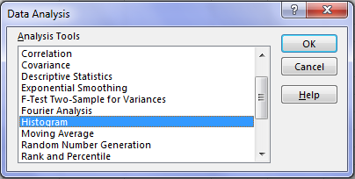

In the histogram dialog box, first, click the Label’s Checkbox as we have labels in our data. After that, In the **Input reference box** select the range **(“Sales Data!D1: D51291”)** of our data and in the **Bin Range Reference box** select **(“Working!K3: K7”)**.In the **Output section**, select range “Working!N3” for a binning table, click Histogram checkbox and then ok.

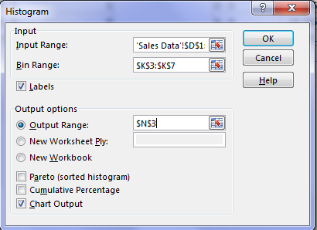

Sample Output

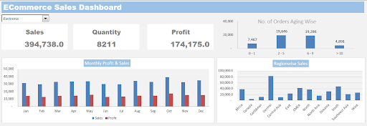

 Note: Sample output is given, please make it a meticulous as per the project statement.